MINI PROJECT ROUND

Real-Time Database Scenario Assessment

Duration: 35 Minutes

Total Marks: 40
Scenario
You are working as a Junior Database Associate for a movie streaming platform.
The management team wants to maintain movie-related information for reporting and analysis purposes.
Your task is to design a small database solution based on the requirements below.

Project Requirements
Create a database for managing movie details.
The system should store:
- Movie information
- Language details
- Ratings
- Collection amounts
This round is intended to evaluate your ability to think and work independently in a real-time project scenario.

Attempt all tasks confidently.
All the best!

Tasks

Task 1 — Database Creation
Create a database suitable for the project.
CREATE DATABASE moviesdb;
USE moviesdb;

Task 2 — Table Creation
Create at least ONE table to store movie details.
The table should contain appropriate columns for:
- Movie ID
- Movie Name
- Language
- Rating
- Collection Amount
Use suitable datatypes.
CREATE TABLE movies(
MovieID INT AUTO_INCREMENT PRIMARY KEY,
MovieName VARCHAR(100),
Language VARCHAR(100),
Rating INT,
CollectionAmount INT);

Task 3 — Constraints
Apply:
- PRIMARY KEY
- AUTO_INCREMENT
wherever required.

Task 4 — Data Insertion
Insert minimum 5 movie records into the table.

INSERT movies(MovieName,Language,Rating,CollectionAmount)
VALUES("Padayaapa","Tamil",5,150000),
("Karuppu","Tamil",4.5,100000),
("Singam","Hindi",3,50000),
("Killi","Tamil",4,100000),
("Premam","Malayalam",5,200000);

Task 5 — Business Requests
Write SQL queries for the following requirements.

Requests

Request #1
Management wants to view all movie details.
SELECT * FROM movies;
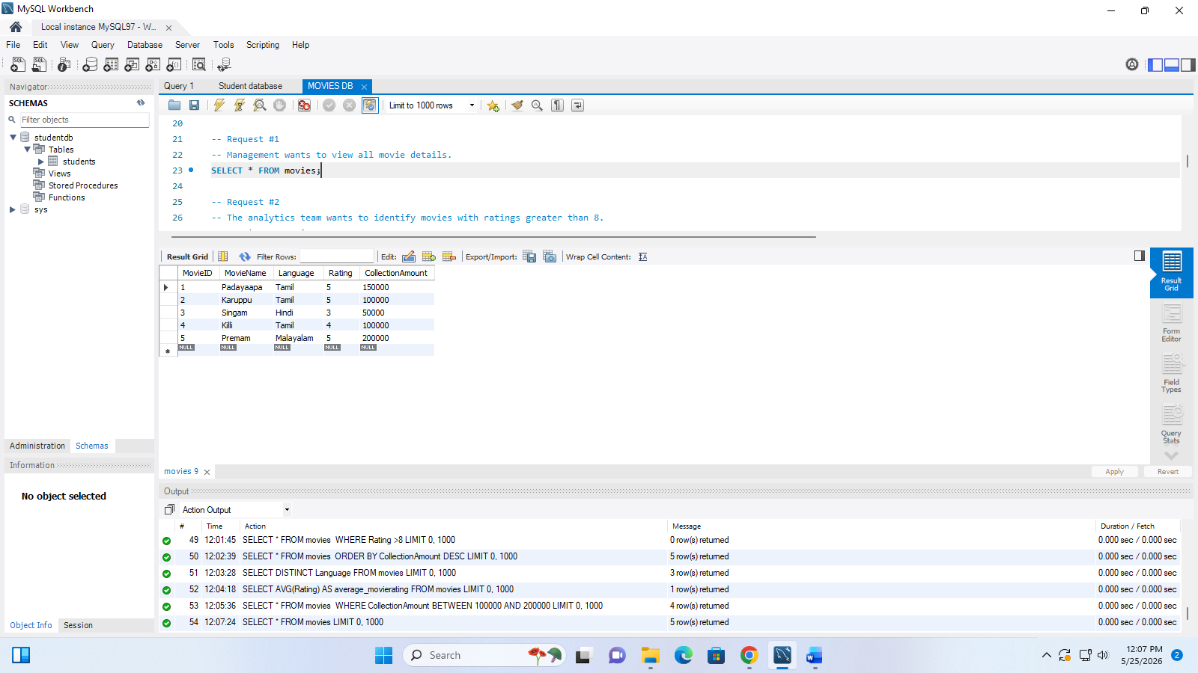

Request #2
The analytics team wants to identify movies with ratings greater than 8.
SELECT * FROM movies
WHERE Rating >8;

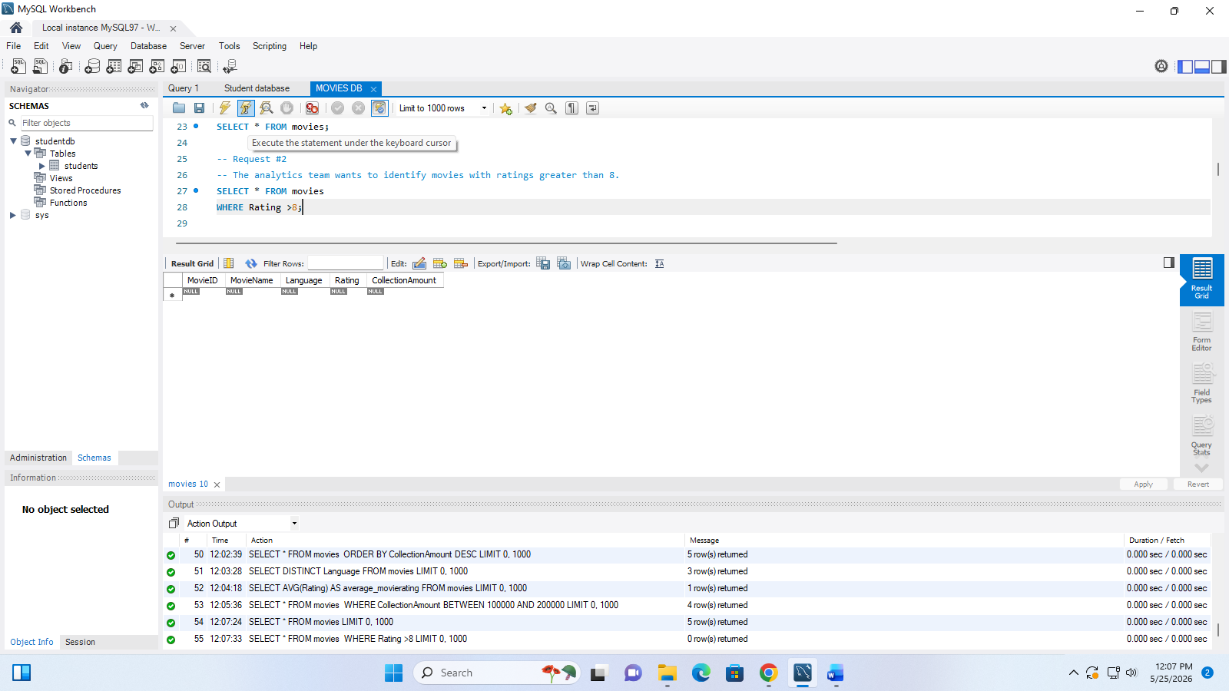

Request #3
The operations team wants movies sorted based on collection amount from highest to lowest.
SELECT * FROM movies
ORDER BY CollectionAmount DESC;
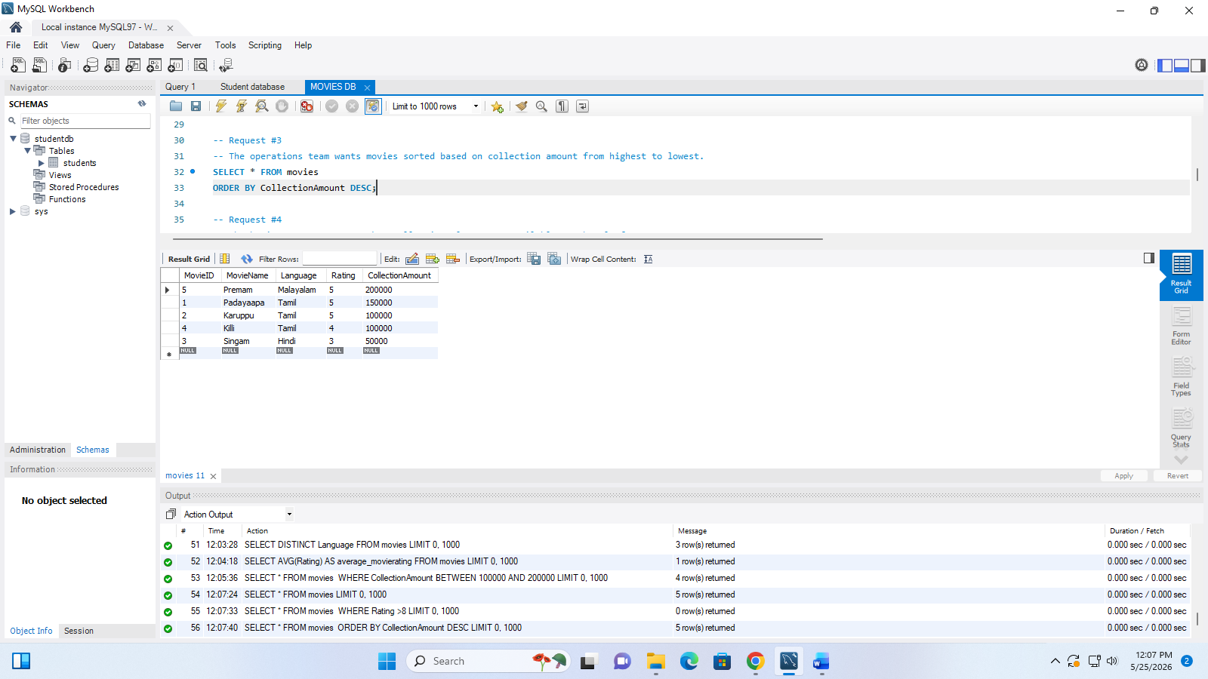
Request #4
The business team wants to know all unique languages available on the platform.
SELECT DISTINCT Language FROM movies;
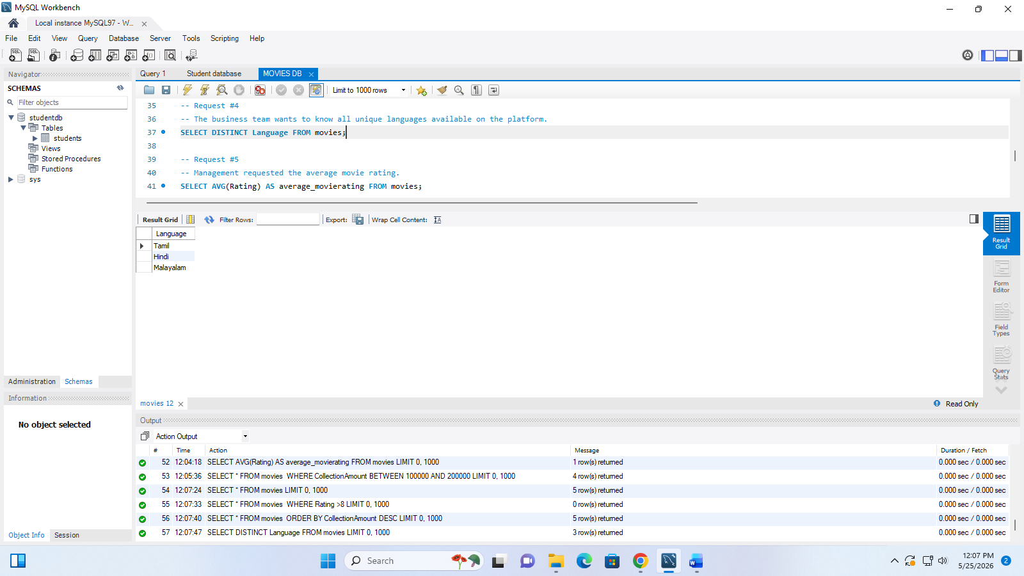
Request #5
Management requested the average movie rating.
SELECT AVG(Rating) AS average_movierating FROM movies;
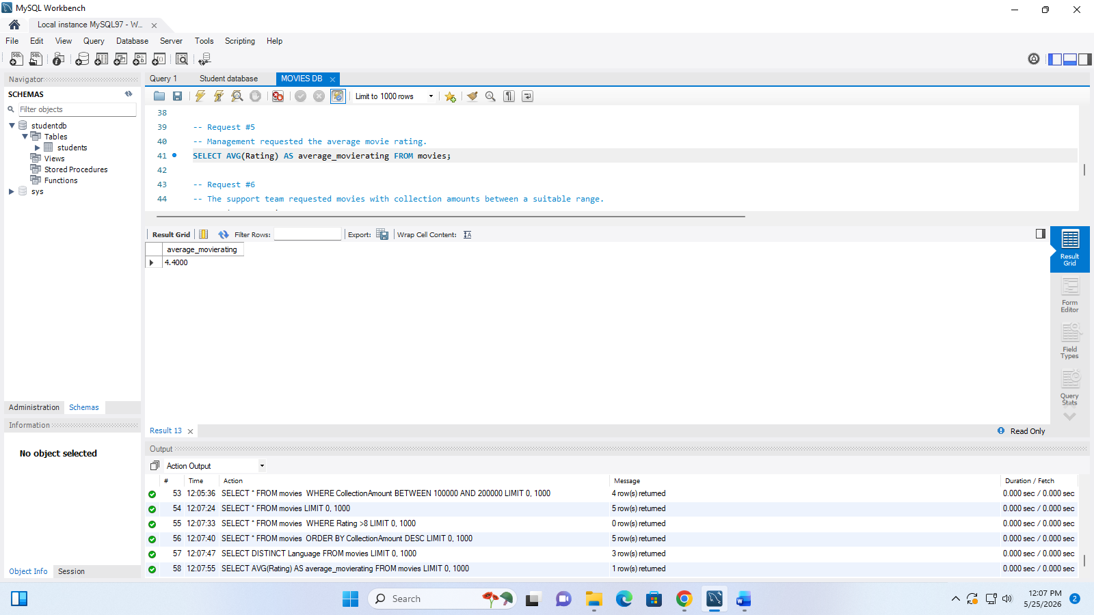
Request #6
The support team requested movies with collection amounts between a suitable range.
SELECT * FROM movies
WHERE CollectionAmount BETWEEN 100000 AND 200000;
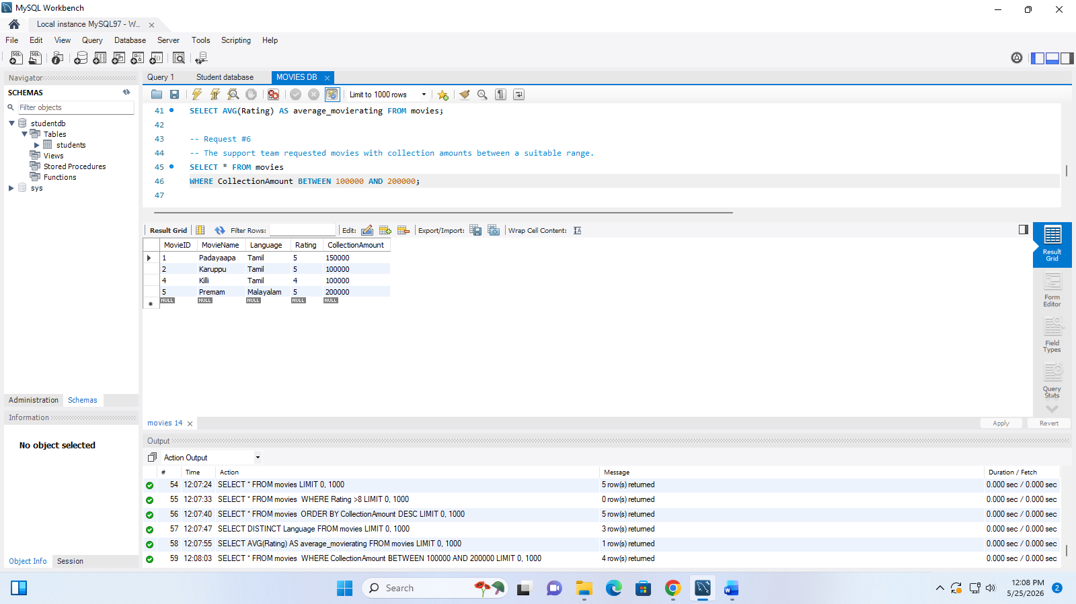

Request #7
After review, one movie rating needs to be updated.
UPDATE movies
SET Rating= 7
WHERE MovieID = 1;

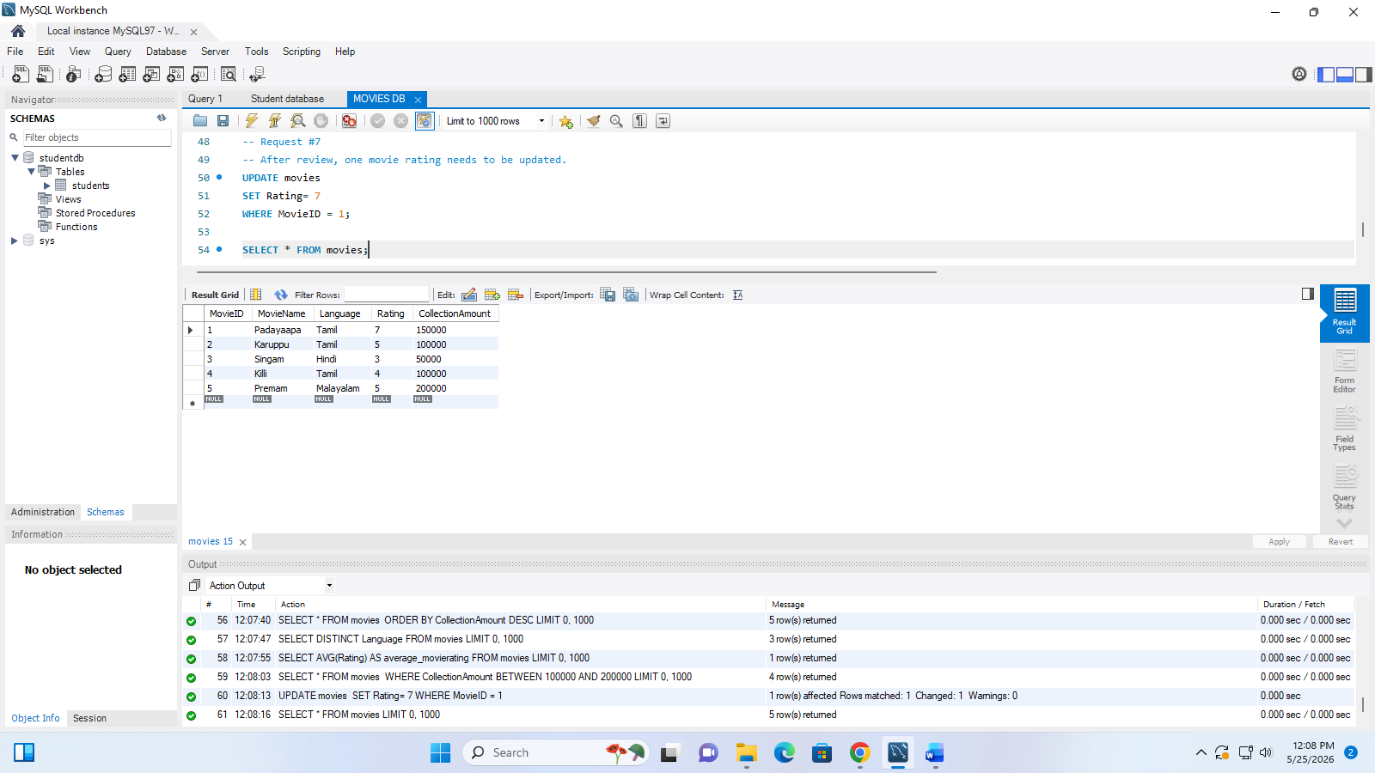

Submission Requirements
Students must submit:
- Database creation query
- Table creation query
- Insert queries
- All business request queries
- Output screenshots

Important Instructions
• Use only concepts taught during training
• Avoid advanced SQL concepts
• Focus on logical thinking and requirement understanding
• Queries should be executable
• Individual work only

Presentation Round
Some students will be selected randomly using a spin wheel.
Selected students must explain:
- Database design
- Datatypes used
- Constraints used
- Query logic
- Requirement understanding

